**SQL: Structured Query Language**

DDL (Data Definition Language) – CREATE, DROP, ALTER

DML (Data Manipulation Language) – SELECT, INSERT, UPDATE, DELETE

DCL (Data Control Language) – GRANT, REVOKE

TCL (Transaction Control Language) – COMMIT, ROLLBACK

Numeric functions: AVG, SUM, MAX, MIN, + - * /, CALC, ROUND, FLOOR, CEILING, RAND, GREATEST, LEAST

String functions: CONCAT, CONCAT_WS, CHAR_LENGTH, TRIM, LTRIM, RTRIM, LEFT, RIGHT, LPAD, RPAD, LIKE, NOT LIKE, UPPER, LOWER

Date & Time functions: DATE_ADD, DATEDIFF, DAYOFWEEK, DAYOFMONTH, YEAR, MONTH, DAY, CURRENT_DATE, CURRENT_TIME

**SELECT**

SQL Functions: COUNT, MIN, MAX, AVG, SUM

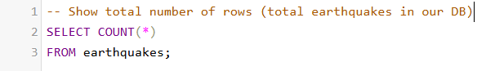

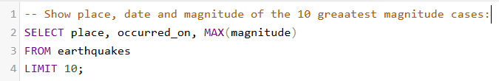

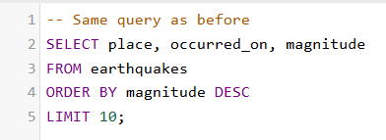

SELECT DISTINCT

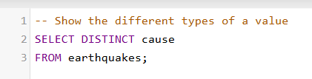

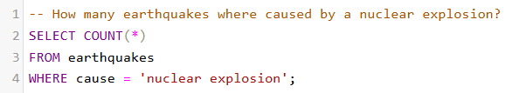

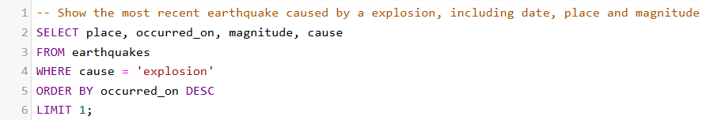

BETWEEN, LIKE

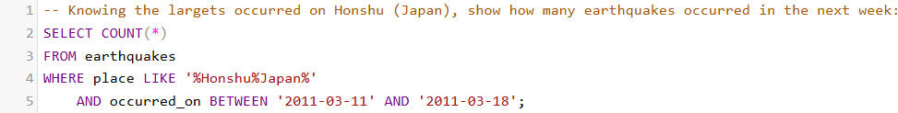

IN

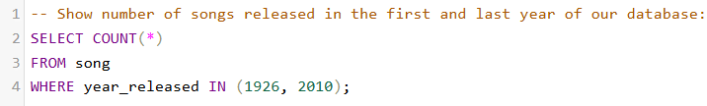

SUBQUERYS

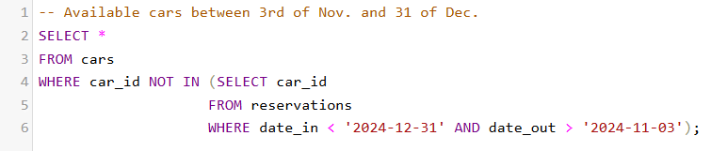

CONCAT / CONCAT_WS



**INSERT**

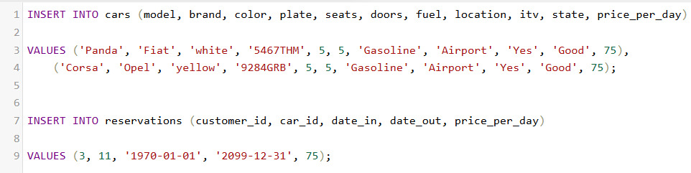

**UPDATE**

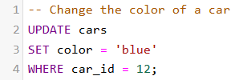

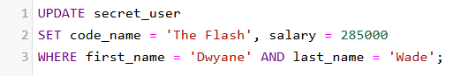

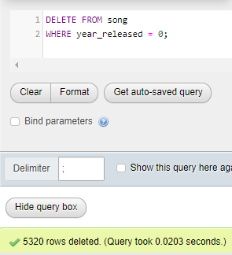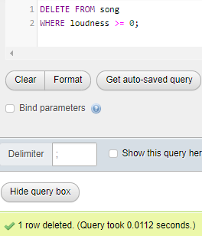**DELETE**